Greetings,

The State of Montana has implemented a security initiative referred to as Multifactor Authentication (MFA) from a vendor called RSA. The added security helps the State meet National Institute of Standards and Technology (NIST) requirements and will protect both state data and your identity.

As of July 30, 2020, MFA will be a requirement for all Citrix access in the form of an RSA software token, installed on a smart phone. Please contact the service desk at 406-444-2000 or servicedesk@mt.gov to receive your software token.

What is Two Factor Authentication?
Two-factor authentication (2FA), often referred to as multi factor authentication (MFA), is a security process in which the user provides two authentication factors to verify they are who they say they are.
Two-factor authentication provides an additional layer of security and makes it harder for attackers to gain access to your computer and online accounts, because knowing the victim's password alone is not enough to pass the authentication check. Two-factor authentication has long been used to control access to sensitive systems and data, and online services are increasingly introducing 2FA to prevent their users' data from being accessed by hackers who have stolen a password database or used phishing campaigns to obtain users' passwords.

What are authentication Factors?
Authentication factors are the methods used to validate a user account on the state network. Authentication methods in the State’s environment fall into two categories:
- Knowledge Factor – Something you know, such as your password.
- Possession Factor – Something you have, such as the RSA SecurID Token we are implementing.

RSA SecureID Tokens
Once all state employees are assigned the security token, State external facing applications such as Web Outlook (OWA), VPN, Citrix and SABHRS Time Entry will require 2FA. SITSD has discovered a “hole” in the Citrix application that needs to be enhanced and enforced for people that are contractors, work remote, etc. Logging into state resources will prompt you to authenticate with the token.
The technology chosen for this implementation is the RSA SecurID tokens. These tokens are available in soft tokens – Software loaded on your smart phone
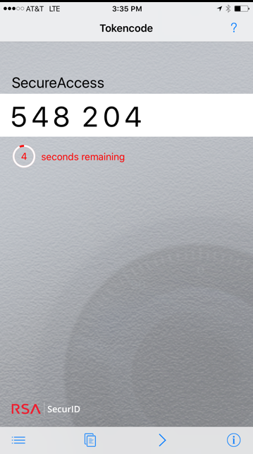
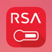
Soft Token – You must carry your smart phone all times to log in through Citrix.
  - Can see what the next code will be.
  - May need to unlock your phone and then open the RSA application to get the token code.
  - If you replace your phone or do a factory reset, the RSA application will need to be re-installed and the Service Desk contacted to activate the application and get it bound to your user account.

How Does It Work?
The RSA SecurID token generates a 6-digit passcode every 60 seconds which is tied to your user account. The timer bar on the left side of the code decreases as it gets closer to changing the passcode. If the timer bar is on the last bar, it is recommended to wait for the timer to reset – this is especially true if accessing external facing applications from remote locations – such as Citrix - since the authentication process does take several seconds to complete.

How to Log on To Your System?
RSA soft tokens on a mobile device work in conjunction with the RSA client installed on your computer. When you are in the RSA Challenge group, you will need to enter your token passcode. Once that is accepted, you will then be asked to enter your normal domain password. Steps are outlined below (images you see may be different than the ones pictured).
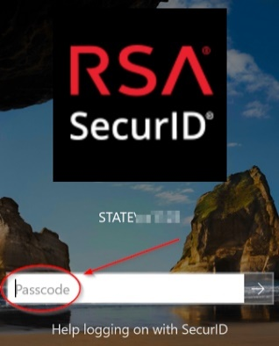
- Enter the token “passcode” and hit the “Enter” key.
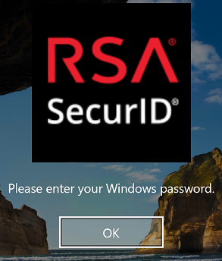
- Once the code is accepted, click the “OK” Button.
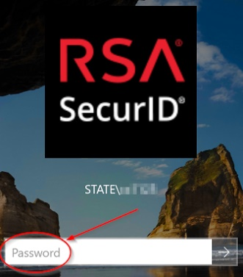
- Enter your “password” and hit the “Enter” key.

Frequently Asked Questions
What happens if I leave my RSA token at home? You must request a temporary 1-day passcode. This must be done daily; no temporary passcodes will be issued for longer than a 24-hour period. You may also use the RSA Self-Service Console on the SITSD Services portal to request a temporary code. This does require access from a pc with internet access. https://mfa.mt.gov/console-selfservice/ Please refer to your Agencies RSA policy or contact your IT professionals for more details.

If I leave my token at home, can I use a co-worker’s token? NO – Each token is assigned to a single user and will not work for another user.

Who do I call if I have issues with the functionality of the RSA secure login? You should work with your IT professionals first and then if necessary, call the SITSD Service Desk.

